**Balochistan University of Engineering & Technology, Khuzdar**

**Department of Energy Systems Engineering**



**LAB MANUAL**

**Applied Physics**

**Name: ________________________**

**Roll No._______________________**

**Semester: _____________________**

**Batch: ________________________**

**Course Incharge: Engr. Nazia Ejaz**

**PLOs, CLOs, Domain and WK for the course of Applied Physics**

**CLO-1.Practice** the basic knowledge of common physical phenomenon’s e.g. current, voltage, resistance, electricity conversion, magnetic field and their effects. [**PLO-1, P-3, WK1]**

**CLO-2.Demonstrate** the application of basic laws of Physics to understand its role in scientific engineering studies and make RC circuits to show their transient behavior. **[PLO-2, P4, WK2]**

**LAB RUBRICS FOR ASSESSING IN-LAB PERFORMANCE (Software based)**

|  |  |  |  |  |  |
| --- | --- | --- | --- | --- | --- |
| **CRITERIA** | **EXCEEDS EXPECTATION**  **(10)** | **MEETS EXPECTATION**  **(6-9)** | **DEVELOPING**  **(2-5)** | **UNSATISFACTORY**  **(0-2)** | **SCORE**  **(0-10)** |
| **Ability to use software** | -Student was familiar with the software and was able to use additional features of the software that were not available in instruction set. | -Student was familiar with the software and required minimal help from the instructor to perform the experiment. | -Student demonstrated an ability to use the software but required assistance from the instructor. | -Student demonstrated little or no ability to perform experiment and required unreasonable amount of assistance from instructor. |  |
| **Ability to follow procedure and/or design a procedure for experiment** | -Student followed the instructions with no assistance.  -Student performed additional experiments or tests beyond those required in instructions.  -If procedure to accomplish an objective is not provided, the student developed a systematic set of tests to accomplish objective. | -Student followed the instructions in the procedure with little or no assistance.  -If procedure was not provided, the student was able to determine an appropriate set of experiments to run to produce stable data and satisfy the lab objectives. | -Student had difficulty with some of the procedure and needed clarification from the instructor.  -If, procedure was not provided, the student needed some direction in deciding what set of experiments to perform to satisfy the lab objectives. | -Student had difficulty reading the procedure and following directions.  -If procedure was not provided, student was incapable of designing a set of experiments to satisfy given lab objectives.  -The data taken was essentially useless. |  |
| **Ability to troubleshoot software** | -Student developed a good systematic procedure for testing software code that allowed for quick identification of problems.  -Student is good at analyzing and quickly solving all technical problems. | -Student demonstrated the ability to test software code in order to identify technical problems, and was able to solve any problems with little or no assistance. | -Student was able to identify the problems in software code but required some assistance in fixing some of the problems. | -Student demonstrated little or no ability to troubleshoot software code for the lab. |  |
| **Q & A** | -Able to explain program design and fundamental concepts correctly and provide alternative solutions. | -Able to explain most of the program design and relevant fundamental concepts. | -Able to explain some program design and relevant fundamental concepts. | -Unable to explain program design or answer relevant fundamental concepts. |  |
| **Data Presentation** | -Student demonstrates diligence in creating a set of visually appealing tables and/or graphs that effectively present the experimental data. | -Experimental data is presented in appropriate format with only a few minor errors or omissions. | -Experimental data is presented in appropriate format but some significant errors are still evident.  -Tables could be better organized or some titles, labels, or units of measure are missing. | -Experimental data is poorly presented.  -Graphs or tables are poorly constructed with several of the following errors: data is missing or incorrect, units are not included, axis labeled, or titles missing. |  |
| **Data Analysis** | -Student provides a very focused and accurate analysis of the data. All observations are stated well and clearly supported by the data. | -Student has analyzed the data, observed trends, and compared experimental results with theoretical results.  -Any discrepancies are adequately addressed.  -All expected observations are made. | -Student has analyzed the data, observed trends, and compared experimental results with theoretical results.  - Any discrepancies are not adequately addressed.  -Some observations that should have been made are missing or poorly supported. | -Student has simply re-stated what type of data was taken with no attempt to interpret trends, explain discrepancies, or evaluate the validity of the data in terms of relevant theory.  -Student lacks understanding of the importance of the results. |  |
| **Writing Style** | -Lab report has no grammatical and/or spelling errors.  -All sections of the report are very well-written and technically accurate. | -Lab report has very few grammatical and/or spelling errors.  -The sentence flow is smooth.  -Student uses technical terms effectively and accurately. | -Lab report has some grammatical and/or spelling errors and is fairly readable.  - Student make effective use of technical terms and rarely resorts to jargon or cliches. | -Lab report has several grammatical and/or spelling errors and sentence construction is poor.  -Student rarely uses technical terms or uses them incorrectly and too often resorts to jargon or cliches. |  |

**LAB RUBRICS FOR ASSESSING IN-LAB PERFORMANCE (Hardware based)**

|  |  |  |  |  |  |
| --- | --- | --- | --- | --- | --- |
| **CRITERIA** | **EXCEEDS EXPECTATION**  **(10)** | **MEETS EXPECTATION**  **(6-9)** | **DEVELOPING**  **(2-5)** | **UNSATISFACTORY**  **(0-2)** | **SCORE**  **(0-10)** |
| **Setup of experiment and implementation (hardware/ simulation)** | -Can identify new ways to setup and implement the experiment without assistance and with detailed understanding of each step. | -Can fully setup the experiment with successful implementation without assistance. | -Can setup most of the experiment with some implementation without assistance. | -Can’t setup the experiment without assistance. |  |
| **Follow the procedure/ design process** | -Follows the procedure/ design process completely and able to simplify or develop alternative procedure/ design. | -Follows the procedure/design process completely. | -Follows most of the procedure/design process with some errors or omissions. | -Doesn’t follow the procedure/ design process. |  |
| **Experimental results** | -Able to achieve all the desired results with new ways to improve measurements/ synthesis. | -Able to achieve all the desired results. | -Unable to achieve all the desired results in implementation without assistance. | -Unable to get the results. |  |
| **Safety** | -Extremely conscious about safety aspects. | -Observes good laboratory safety procedures. | -Unsafe lab procedures observed infrequently. | -Practices unsafe, risky behaviors in lab. |  |
| **Viva** | -Able to explain design, simulation, implementation and fundamental concepts correctly and provide alternative solutions. | -Able to explain design, simulation, implementation and fundamental concepts correctly. | -Able to explain some design and relevant fundamental concepts. | -Unable to explain design and answer relevant fundamental concepts. |  |
| **Data Presentation** | -Student demonstrates diligence in creating a set of visually appealing tables and/or graphs that effectively present the experimental data. | -Experimental data is presented in appropriate format with only a few minor errors or omissions. | -Experimental data is presented in appropriate format but some significant errors are still evident.  -Tables could be better organized or some titles, labels, or units of measure are missing. | -Experimental data is poorly presented.  -Graphs or tables are poorly constructed with several of the following errors: data is missing or incorrect, units are not included, axis labeled, or titles missing. |  |
| **Data Analysis** | -Student provides a very focused and accurate analysis of the data. All observations are stated well and clearly supported by the data. | -Student has analyzed the data, observed trends, and compared experimental results with theoretical results.  -Any discrepancies are adequately addressed.  -All expected observations are made. | -Student has analyzed the data, observed trends, and compared experimental results with theoretical results.  - Any discrepancies are not adequately addressed.  -Some observations that should have been made are missing or poorly supported. | -Student has simply re-stated what type of data was taken with no attempt to interpret trends, explain discrepancies, or evaluate the validity of the data in terms of relevant theory.  -Student lacks understanding of the importance of the results. |  |
| **Writing Style** | -Lab report has no grammatical and/or spelling errors.  -All sections of the report are very well-written and technically accurate. | -Lab report has very few grammatical and/or spelling errors.  -The sentence flow is smooth.  -Student uses technical terms effectively and accurately. | -Lab report has some grammatical and/or spelling errors and is fairly readable.  - Student make effective use of technical terms and rarely resorts to jargon or clichés. | -Lab report has several grammatical and/or spelling errors and sentence construction is poor.  -Student rarely uses technical terms or uses them incorrectly and too often resorts to jargon or clichés. |  |

**LIST OF PRACTICLES**

|  |  |  |  |  |  |  |
| --- | --- | --- | --- | --- | --- | --- |
| **S.No** | **Lab Objectives** | **PLO** | **CLO** | **Domain** | **WK** | **Remarks** |
|  | To **practice** Ohm’s Law to find linear relationship of current and voltage. |  |  |  |  |  |
|  | To practice the transformation of Direct-Current into Heat and Light. |  |  |  |  |  |
|  | To practice resistors in parallel and series. |  |  |  |  |  |
|  | **Demonstration** of force produced on a current carrying conductor when placed in the magnetic field |  |  |  |  |  |
|  | Demonstration of force produced between two parallel current carrying conductors. |  |  |  |  |  |
|  | Demonstration of the magnetic field setup around the current carrying conductor. |  |  |  |  |  |
|  | Familiar with the phenomenon of electromagnetic induction on which the production of induced e.m.f is based. |  |  |  |  |  |
|  |  |  |  |  |  |  |
|  |  |  |  |  |  |  |
| 10. |  |  |  |  |  |  |
| 11. |  |  |  |  |  |  |
| 12. |  |  |  |  |  |  |

**Lab #01**

**Object:**

**Apparatus:**

Voltmeter, Ammeter, DC power Supply, Decade Resistance Box, Connecting Lead.

**Theory:**

The most basic quantities of electricity are voltage, current and resistance. Ohm's law shows a simple relationship between these three quantities, hence this law can be considered as the most basic law of electrical engineering. This simple, easiest to remember, three character law of electrical engineering helps to calculate and analyze electrical quantities related to power, efficiency and impedance. The statement of Ohm’s law is simple, and it says that whenever a potential difference or voltage is applied across a resistor of a closed circuit, current starts flowing through it. This current is directly proportional to the voltage applied if temperature and all other factors remain constant. Thus we can mathematically express it as:

*V* ∝*I*

Now putting the constant of proportionality we get,

*V*=*IR*

This particular equation essentially presents the statement of this law where I is the current through the resistor, measured in Ampere (Ampere, or amps), when the electric potential difference V is applied across the resistor in unit of volt, and ohm (Ω) is the unit of measure for the resistance of the resistor R. It’s important to note that the resistance R is the property of the conductor and theoretically has no dependence on the voltage applied, or on the flow of current. The value of R changes only if the conditions (like temperature, diameter length etc.) of the material are changed by any means.

The applications of ohm’s law are that it helps us in determining either voltage, current or resistance of a linear circuit when the other two quantities are known to us.

Apart from that, it makes power calculation a lot simpler, like when we know the value of the resistance for a particular circuit, we need not know both the current and the voltage to calculate the power dissipation since P = VI. Rather we can use Ohm’s Law

*V*=*IR I*=*V R*

To replace either the voltage or current in the above expression to produce the result

*P*=*VI*=*V*2 *R*

=*I*2*R*

These are the applications of Ohm’s law as we can see from the results that the rate of energy loss varies with the square of the voltage or current. When we double the voltage applied to a circuit, obeying Ohm’s law, the rate at which energy is supplied (or power) gets four times

Bigger. This phenomenon occurs because increasing the voltage also makes the current rise by the same amount as it has been explained above.

**Limitation of Ohm’s Law:** The limitations of Ohm’s law are explained as follows:

1. This law cannot be applied to unilateralnetworks.

A unilateral network has unilateral elements like diode, transistors, etc., which do not have same voltage current relation for both directions of current.\

1. Ohm’s law is also not applicable for non – linearelements.

Non – linear elements are those which do not give current through it, is not exactly proportional to the voltage applied, that means the resistance value of those elements changes for different values of voltage and current. Examples of non – linear elements are thermistor, electric arc, etc.

**Procedure:**

The experiment setup consists of a simple circuit with a variable resistance and simple power source, which are 3 batteries (1.5 Volt each). The diagram beside shows the single circuit that we will use for this experiment: Choose a Voltage range and then vary the value of the resistance over the range. As expected from Ohm’s law, it will be seen the voltage range and value of the resistance chosen will be linear and the value of resistance will be perpendicular to the current.

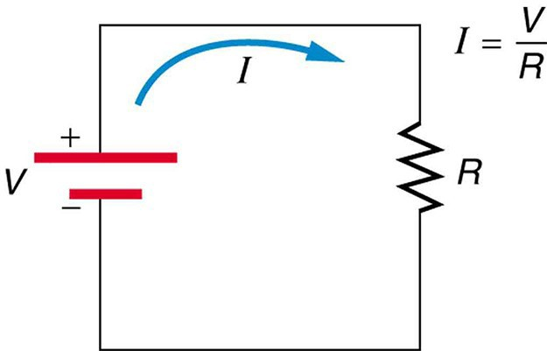

1. Set up the apparatus to be the circuit as shown in diagram ofhypothesis.
2. Set the value of electromotive force into 3V.
3. Put the 12-ohm resistor and see the value of current in theMultimeter.
4. Change the 12-ohm resistor with 82 and 470-ohm resistor varied and repeat step3.
5. Change the value of electromotive force into 6V.
6. Repeat steps 3 and 4 (use 56-ohm resistor instead of 12-ohm resistor, because the value of 12-ohm resistor is too small for 6V of electromotiveforce).

**Observations:**

|  |  |  |  |  |  |  |  |  |  |  |  |
| --- | --- | --- | --- | --- | --- | --- | --- | --- | --- | --- | --- |
| **End ‘A’** | | | | | | **End ‘B’** | | | | | |
| **Length**  **(cm)** | **Time for ten**  **Vibrations (sec)** | | | **Mean**  **(sec)** | **Time period**  **T/10 (sec)** | **Length**  **(cm)** | **Time for ten**  **Vibrations (sec)** | | | **Mean**  **(sec)** | **Time period**  **T/10 (sec)** |
|  |  |  |  |  |  |  |  |  |  |  |  |
|  |  |  |  |  |  |  |  |  |  |  |  |
|  |  |  |  |  |  |  |  |  |  |  |  |
|  |  |  |  |  |  |  |  |  |  |  |  |
|  |  |  |  |  |  |  |  |  |  |  |  |
|  |  |  |  |  |  |  |  |  |  |  |  |
|  |  |  |  |  |  |  |  |  |  |  |  |
|  |  |  |  |  |  |  |  |  |  |  |  |
|  |  |  |  |  |  |  |  |  |  |  |  |
|  |  |  |  |  |  |  |  |  |  |  |  |

**Calculations:**

Plot a graph between distance from center of gravity (along horizontal axis) and time period (along vertical axis). Draw both parts of the graph on the same paper with same scale. Take y-axis in the middle, on right side plot the data obtained from the holes between A and C, and on left side plot the data obtained from the holes between B and C.

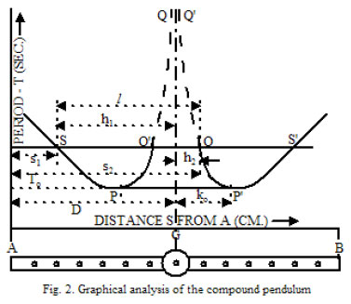

Measure the distances SQ (l1) and PC (l2). Take the average of l1 and l2 this gives the length of equivalent simple pendulum. Substitute the values in the working formula and evaluate the value of ‘g’ acceleration due to gravity.

**Calculations for L:**

* L = L1 + L2 / 2

**Calculations for g:**

|  |  |
| --- | --- |
|  |  |
|  |  |
|  |  |
|  |  |
|  |  |

**Mean of g:**

**Result:**

* The value of acceleration due to gravity is found to be _________________ m/sec2

**Precaution and Sources of Error:**

1. The stand should be rigid.
2. The motion of the pendulum should be in one plane.
3. Amplitude of the vibration must be small.
4. Support and knife edge should be firm.

Air may cause buoyancy and drag.

**Lab #02**

**Object:** To determine the value of surface tension of water by capillary method using a capillary tube and a needle. Also calculate the percentage error.

**Apparatus:**

* A fusion tube (or small test tube)
* Five capillary tubes of different diameters
* Centimeter scale
* Two rubber bands
* Sewing needle of No.1 to No. 5
* Stand with clamp
* Beaker containing water
* Micrometer screw gauge
* Thermometer
* Erasure

**Theory**:

Surface tension of a liquid is the force per unit length acting on either side of line drawn on the liquid surface. The direction of the force is tangential to the surface and perpendicular to the line.

* + - * Surface tension = Force/Length

When a narrow tube is dipped in a liquid, the rising (or sinking) of the liquid in the capillary tube is called “Capillarity”

**Working formula:**

The surface tension of water is given by:

T = рghr/2

Where

* r is the inner radius of the capillary tube
* h is the height of water in the capillary tube
* р is density of water (at room temperature)

**Procedure:**

1. Take a fusion tube and five capillary tubes (of diameters, from 0.8mm to 1.5 mm)
2. Fill the fusion tube with water. Fasten the tube with a plastic scale using a rubber band, and then clamp it with a stand.
3. Note temperature of water by dipping a thermometer in water contained in the fusion tube. Put a thin erasure behind the capillary tube and fasten it to the scale using another rubber band.
4. Dip the lower end of the first capillary tube in the water contained in the fusion tube. Put a thin erasure behind the capillary tube and fasten it to the scale using another rubber band.
5. Fix the scale in the clamp of an iron stand vertically.
6. Push the capillary tube a little more into the water and then bring it to the original position. This will wet the tube above the point reached by water. If the level of water does not come at that position then clean the capillary tube.
7. Note the position h1 of the lower meniscus of the water in the fusion tube.
8. Also note the position h2 of the meniscus in the capillary tube.
9. Calculate height h of the capillary rise, where h = h2 – h1.
10. Remove the capillary tube from the scale.
11. Take a sewing needle and insert it in the bore of the capillary. If this needle does not fit in the bore, replace it with the other one. When the needle fits in the bore, put a mark with ink pen at this position on the needle just outside the capillary.
12. Measure the diameter D of the needle at the ink mark by a micrometer screw gauge. Find the radius (r) by having the diameter.
13. Calculate the surface tension of water using the formula: T = рghr/2
14. Repeat the steps 4 to 13 using four more capillary tubes of different diameters.

**Observation:**

**I. Height of Water in Capillary**

|  |  |  |  |  |  |
| --- | --- | --- | --- | --- | --- |
| **S. No** | **Water level in fusion tube h1 (cm)** | **Water level in capillary tube h2 (cm)** | **Height of water column**  **h = h2 – h1** | **Inner radius of capillary (r) (cm)** | **Surface tension T**  **Dyne/cm** |
| **1**  **2**  **3** |  |  |  |  |  |

**II. Inner Radius of the Capillary by Screw Gauge**

* Least count L.C = pitch/number of C.S Div = __________ cm
* Zero error, Z = ______ div = ________ x 0.001 = _______ cm

|  |  |  |  |  |  |  |
| --- | --- | --- | --- | --- | --- | --- |
| **S.No** | **Main scale (MS) cm** | **Circular scale (CS) div** | **Fractional part**  **FP = CS x LC** | **Total Reading**  **T = MS + FP** | **Corrected Reading = Diameter**  **D = T - Z** | **Inner radius of capillary**  **r = D/2** |
| **1**  **2**  **3** |  |  |  |  |  |  |

**Calculations:**

Surface Tension:

T1 = рghr/2 = __________ dyne/cm

T2 = рghr/2 = __________ dyne/cm

T3 = рghr/2 = __________ dyne/cm

Mean T = ---------- + --------- + ------------ / 3 = ________ dyne/cm

**Percentage Error:**

Standard value of surface tension of water = 72.0 dyne/cm

Percentage error = Standard value – calculated value/standard value x 100 = ________ %

**Results:**

The surface tension of water = ____________ dyne/cm.

Percentage error = _____________ %

**Lab #03**

**Object:**

To calculate Dynamic Viscosity of glycerin using stokes apparatus.

**Apparatus:**

* Stoke apparatus with graduated cylinder,
* Glycerin,
* Metallic ball with hook,
* Stop watch.

**Theory:**

A body in a fluid is acted on by a frictional force in the opposite direction to its direction of travel. The magnitude of this force depends on the geometry of the body, its velocity and internal friction of the fluid. A measure for the internal friction is given by the dynamic viscosity µ. For a sphere of radius r moving at velocity V in an infinitely fluid of dynamic viscosity µ

F1 = 6 πµr V (Frictional Force)

If the sphere falls vertically in the fluid, after a time, it will move at a constant velocity V, and all the forces acting on the sphere will be in equilibrium.

F2 = 4/3 πr3*ρ*1g (Buoyant Force)

F3 = 4/3 πr3*ρ*2g (Gravitational Force)

*ρ*1= density of fluid

*ρ*2 = density of sphere

g = gravitational acceleration

The viscosity can, therefore be determined by measuring the rate of fall V:

µ = [2r2 (*ρ*2 – *ρ*1) g]/ 9V

**Data:**

*ρ*1 = density of fluid = 1259.37 kg/m3

**Procedure:**

1. Find the mass of sphere using triple beam balance.
2. Find the radius of sphere using triple beam balance.
3. Tie a string to the sphere and dip it into the fluid.
4. As the sphere goes down, note the time at distance of 20cm.
5. Repeat the 4th step and get the mean velocity of glycerine.
6. Calculate the density and dynamic viscosity.

Ƞ = [2r2(S2-S1)g] / 9V

**Observation:**

Mass of empty beaker = ____________g

Mass of beaker + sphere = _____________g

Mass of sphere = ________ g

r = radius of sphere = _______ m [M.S + (V.S X LC)]

|  |  |  |  |  |
| --- | --- | --- | --- | --- |
| **S. No** | **Distance (m)** | **Time (sec)** | **Radius (m)** | **V (m/s)** |
| **1** |  |  |  |  |
| **2** |  |  |  |  |
| **3** |  |  |  |  |

**Calculations:**

Diameter of sphere = ____________

Radius of sphere = ______________

Volume of sphere:

Vol= _______ cm3

*ρ*2 = density of sphere = _________ kg/ m3

Mean Velocity = _______ m/s

Dynamic viscosity:

**Lab #04**

**Object:**

Measurement of Buoyant and Upward Force.

**Apparatus:**

Density set, String, Overflow can, Beaker for catching water, Graduated cylinder, Triple-beam balance.

**Theory:**

**ARCHIMEDES’ PRINCIPLE**

Archimedes’ Principle states that the buoyant force exerted on an object partially or fully submerged in a fluid will be equal to the weight of the fluid displaced by the object.

**UPWARD FORCE**

When an object is submerged in a fluid, the apparent weight of the object is less than the weight in air because of the **buoyant force**.

An upward force is any force that counteracts the force of gravity. In science, buoyancy is an upward force exerted by a fluid that opposes the weight of an immersed object.

**Procedure:**

1. Find mass of beaker.
2. Find mass of beaker having water in it.
3. Find mass of water by subtracting the mass of empty beaker from the mass of beaker having water.
4. Find out the weight of displaced water using triple beam balance.
5. Find out the weight of given samples in air.
6. Now find out the buoyant force of each sample by subtracting weight in air from weight in water of each sample.

**Observation and Calculations:**

Mass of empty beaker = ____________

|  |  |  |  |
| --- | --- | --- | --- |
| **Object** | **Mass of Beaker + Water** | **Mass of Water** | **Weight of Displaced Water** |
| Al. Cylinder |  |  |  |
| Brass Block |  |  |  |
| Al. Irregular Shaped Block |  |  |  |

|  |  |  |  |
| --- | --- | --- | --- |
| **Object** | **Weight in Air (a)** | **Weight in Water (b)** | **B.F = a - b** |
| Al. Cylinder |  |  |  |
| Brass Block |  |  |  |
| Al. Irregular Shaped Block |  |  |  |

**Questions:**

1. In each case, is the buoyant force found using the difference between weights equal to the weight of the water displaced?

2. Was the weight of objects different in water than air? If yes then write it’sreason.

**Lab #05**

**Object:**

Measurement of pressure at different flow rates using Venturi Apparatus.

**Apparatus:**

Fluid tubing, Restriction clamps, Water reservoir, Sink container, Table clamp, 120 cm rod, Stop watch, Quad Pressure Sensor and three finger clamps.

**Theory:**

In the Venturi Apparatus, air or water flows through a channel of varying width. As the cross-sectional area changes, volumetric flow rate remains constant, but the velocity and pressure of the fluid vary. With a Quad Pressure Sensor connected to the built-in Pitot tubes, the Venturi Apparatus allows the quantitative study and verification of Bernoulli’s principle and the Venturi effect.

**Bernoulli's principle**

Within a horizontal flow of fluid, points of higher fluid speed will have less pressure than points of slower fluid speed.

**Venturi effect**

When a fluid moving through a pipe faces a constriction, or narrowing of the pipe, the velocity of flow increases at the constriction, with a corresponding drop in the static pressure. This principle is called the Venturi effect.

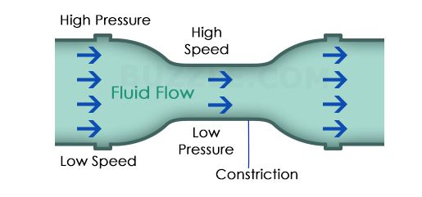

**Relation between Bernoulli’s principle and Venturi effect**

According to Bernoulli's principle, the flow speed of a fluid is inversely proportional to its static pressure. This means that, when the velocity of the fluid increases, its pressure will decrease. The Venturi effect is a version of the Bernoulli's principle, but more specifically suited to the flow of fluids through a pipe.

The Venturi effect can also be proven by studying Bernoulli's equation, which is:

( v2/2 ) + gh + ( P/ρ ) = Constant

Here,

v is the flow velocity

g is the gravitational constant

h is the elevation, in the direction opposite to gravity

P is the pressure at any point in the fluid

ρ is the mass density

Since the total sum on the left-hand side of the equation remains constant at a given height, any increase in the flow velocity should be balanced by decreasing another variable in the equation, so that the sum remains constant. But at any given height, g, h, and ρ are constants, i.e., their values remain the same. Therefore, an increase in the velocity 'v', can only result in the decrease in the pressure 'P', so that Bernoulli's equation is followed. Thus, when a fluid flows through a constriction, its flow speed increases with a decrease in the static pressure.

**Venturi Apparatus**

An incompressible fluid of density ρ flows through a pipe of varying diameter. As the cross-sectional area decreases from A0 (large) to A (small), the speed of the fluid increases from υ0 to υ. The flow rate, R, (volume/time) of the fluid through the tube is related to the speed of the fluid (distance/time) and the cross-sectional area of the pipe. The flow rate must be constant over thelength of the pipe. This relationship is known as the ContinuityEquation, and can be expressed as

(eq. 1) R = A0υ0 = Aυ

As the fluid travels from the wide part of the pipe to the constriction, the speed

increases from υ0 to υ, and the pressure decreases from P0 to P. If the pressure

change is due only to the velocity change, Bernoulli's Equation can be simplified to:

(eq. 2) P = P0 – 1/2 P(υ2 - υ0 2 )

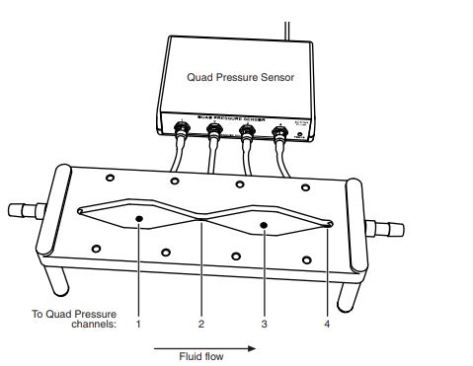

**Procedure:**

1-Connect the Quad Pressure Sensor to your PASPORT interface (but do not connect tubing to the pressure ports yet). If you are using a computer, start DataStudio.

2. Calibrate the Quad Pressure Sensor if it’s not calibrated.

3. Connect each of the four pressure tubes extending from the underside of the apparatus to the ports of the Quad Pressure Sensor.

4. Set up the fluid supply and flow-rate measurement.

5. Start fluid flow.

6. Start data collection on the computer or interface.

7. Continue data collection while observing the pressure measurements on a graph

display. Obtain the results at 2, 4, 6, 8 and 10 seconds interval.

8. View your data on a graph of pressure versus time by selecting absolute pressure (KPa) on y-axis and time on x-axis.

9. Select a time interval of about 2 seconds in which all off the pressure measurements are relatively clean (though not necessarily constant or noise-free).

10. Within this time interval, determine the average of each pressure measurement:

P1, P2, P3 and P4.

11. Over the same 2-second interval, determine the average flow rate, R. Repeat the same for 4, 6,8 and 10 seconds respectively.

**Observation:**

|  |  |  |  |  |
| --- | --- | --- | --- | --- |
| **Time** | **Absolute Pressure 1** | **Absolute Pressure 2** | **Absolute Pressure 3** | **Absolute Pressure 4** |
| 2 sec |  |  |  |  |
| 4 sec |  |  |  |  |
| 6 sec |  |  |  |  |
| 8 sec |  |  |  |  |
| 10 sec |  |  |  |  |

**Tasks:**

1. Interpret the observations and graph in your lab report.
2. Explain the venturi effect with reference to continuity equation.
3. How is the pressure varying with different clamp positions?

**Lab #06**

**Object:**

Simulated demonstration of the laws of heat dynamics (heat transfer) experiment exhibiting the principle.

**Apparatus:**

* Hollow metal can
* Hot water
* Styrofoam cup
* Cold water
* thermometer

**Working formula:**

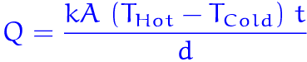

Where k is the thermal conductivity of the material,

  A is the cross sectional area,  
  THotis the higher temperature,  
  TCold is the cooler temperature,  
  t is the time taken,  
  d is the thickness of the material.

**Theory:**

* In conduction, heat is transferred from a hot temperature location to a cold temperature location. The transfer of heat will continue as long as there is a difference in temperature between the two locations.
* Once the two locations have reached the same temperature, thermal equilibrium is established and the heat transfer stops. The transfer of heat for a situation involving a metal can containing high temperature water that was placed within a Styrofoam cup containing low temperature water. If the two water samples are equipped with temperature probes that record changes in temperature with respect to time, then the following graphs are produced.

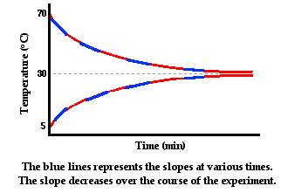

* In the graphs above, the slope of the line represents the rate at which the temperature of each individual sample of water is changing. The temperature is changing because of the heat transfer from the hot to the cold water.
* The hot water is losing energy, so its slope is negative. The cold water is gaining energy, so its slope is positive. The rate at which temperature changes is proportional to the rate at which heat is transferred.
* The temperature of a sample changes more rapidly if heat is transferred at a high rate and less rapidly if heat is transferred at a low rate. When the two samples reach thermal equilibrium, there is no more heat transfer and the slope is zero. So we can think of the slopes as being a measure of the rate of heat transfer.
* Over the course of time, the rate of heat transfer is decreasing. Initially heat is being transferred at a high rate as reflected by the steeper slopes. And as time progresses, the slopes of the lines are becoming less steep and more gently sloped.
* As thermal equilibrium is approached, their temperatures are approaching the same value. With the temperature difference approaching zero, the rate of heat transfer approaches zero. In conclusion, the rate of conductive heat transfer between two locations is affected by the temperature difference between the two locations.
* Driving force for the heat transfer is the temperature difference between any two bodies. Two bodies at different temperatures when in contact tend to attain the same temperature by heat transfer. This phenomenon is used in reactors to heat or cool the medium to desired temperature. To determine the flow rate temperature of the heating or cooling substances, such that the operation of heating or cooling is performed effectively and efficiently. It is necessary to know the overall heat transfer coefficient ‘U’. The transferred is proportional to the temperature gradient and inversely proportional to the area.

Hence,

**Q α A ΔT (or) Q = U A ΔT**

**Procedure:**

* Place hollow metal can in Styrofoam cup.
* Fill the can with cold water and Styrofoam cup with hot water.
* Hot water of about 70 degree C and cold water of about 5 degree C.
* Measure the initial temperatures of water and temperature of room or environment.
* Give it some time for conduction of heat and finally measure the water in can and in Styrofoam.

**Diagram:**

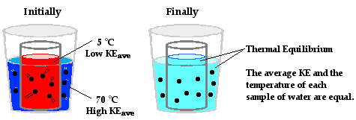

**Observation:**

The difference in temperature between the two containers of water. Initially, when the rate of heat transfer is high, the hot water has a temperature of 70°C and the cold water has a temperature of 5°C. The two containers have a 65°C difference in temperature. As the hot water begins to cool and the cold water begins to warm, the difference in their temperatures decrease and the rate of heat transfer decreases.

**Result:**

The mechanism in which heat is transferred from one object to another object through particle collisions is known as conduction. In conduction, there is no net transfer of physical stuff between the objects. Nothing material moves across the boundary. The changes in temperature are wholly explained as the result of the gains and losses of kinetic energy during collisions.

**Lab #07**

**Object:**

Demonstration of Law of reflection and Snell’s Law and to test your knowledge of:

* Reflection of light through a plain mirror
* Refraction of light through a prism

**Theory:**

* **Reflection of light through a plain mirror**

**Reflection of light:** When light rays traveling in a medium reaches the boundary of other medium, they turn back to the first medium. This phenomenon of turning back of light into the same medium after striking the boundary of other medium is called Reflection of Light.

## Law of Reflection: The law of reflection governs the reflection of light-rays off smooth conducting surfaces, such as polished metal or metal-coated glass mirrors. Consider a light-ray incident on a plane mirror, as shown in Fig. The law of reflection states that the incident ray, the reflected ray, and the normal to the surface of the mirror all lie in the same plane. Furthermore, the angle of reflection $r$ is equal to the angle of incidence$i$. Both angles are measured with respect to the normal to the mirror.

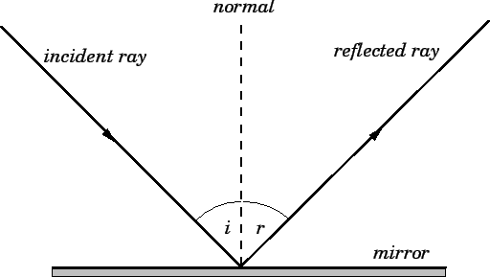

Figure: The law of reflection

The law of reflection also holds for non-plane mirrors, provided that the normal at any point on the mirror is understood to be the outward pointing normal to the local tangent plane of the mirror at that point. For rough surfaces, the law of reflection remains valid. It predicts that rays incident at slightly different points on the surface are reflected in completely different directions, because the normal to a rough surface varies in direction very strongly from point to point on the surface. This type of reflection is called diffuse reflection, and is what enables us to see non-shiny objects.

**Procedure**

1. Place the light source in ray-box mode on a blank sheet of white paper. Turn the wheel to select a single ray.

2. Place the mirror on the paper. Position the plane (flat) surface of the mirror in the path of the incident ray at an angle that allows you to clearly see the incident and reflected rays.

3. On the paper, trace and label the surface of the plane mirror and the incident and reflected rays. Indicate the incoming and the outgoing rays with arrows in the appropriate directions.

4. Remove the light source and mirror from the paper. On the paper, draw the normal to the surface (as in fig)

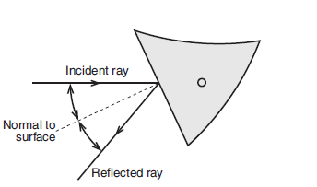

5. Measure the angle of incidence and the angle of reflection. Measure these angles from the normal. Record the angles in the first row of table.

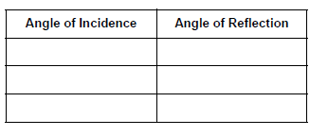

6. Repeat steps 1–5 with a different angle of incidence. Repeat the procedure again to complete table with three different angles of incidence.

7. Turn the wheel on the light source to select the three primary color rays. Shine the colored rays at an angle to the plane mirror. Mark the position of the surface of the plane mirror and trace the incident and reflected rays. Indicate the colors of the incoming and the outgoing rays and mark them with arrows in the appropriate directions.

* **Refraction of light through a prism**

**Refraction of light:** Refraction is the bending of a wave when it enters a medium where its speed is different. The refraction of light when it passes from a fast medium to a slow medium bends the light ray toward the normal to the boundary between the two media. Refraction is responsible for image formation by [lenses](http://hyperphysics.phy-astr.gsu.edu/hbase/geoopt/lenscon.html#c1) and the [eye](http://hyperphysics.phy-astr.gsu.edu/hbase/vision/eye.html#c1).

### Snell's Law: Like with reflection, refraction also involves the angles that the incident ray and the refracted ray make with the normal to the surface at the point of refraction. Unlike reflection, refraction also depends on the media through which the light rays are travelling. This dependence is made explicit in Snell's Law via refractive indices, numbers which are constant for given media.

When a monochromatic light ray crosses from one medium (such as air) to another (such as acrylic), it is refracted. According to Snell’s Law,

*n*1sin θ1 = *n*2sin θ2

the angle of refraction (θ2) depends on the angle of incidence (θ1) and the indices of refraction of both media (*n*1 and *n*2), as shown in Figure. Because the index of refraction for light varies with the frequency of the light, white light that enters the material (at an angle other than 0°) will separate into its component colors as each frequency is bent a different amount. The trapezoid is made of acrylic which has an index of refraction of 1.497 for light of wavelength 486 nm in a vacuum (blue light), 1.491 for wavelength 589 nm (yellow), and 1.489 for wavelength 651 nm (red). In general for visible light, index of refraction increases with increasing frequency.

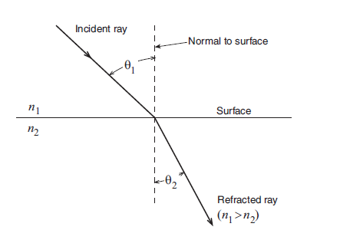Snell's Law is given in the following diagram.

Fig: Snellen’s law

**Procedure**

1.Place the light source in ray-box mode on a sheet of blank white paper. Turn the wheel to select a single white ray.

2.Position the trapezoid as shown in Figure. The acute-angled end of the trapezoid is used as a prism in this experiment. Keep the ray near the point of the trapezoid for maximum transmission of the light.

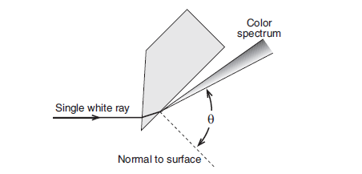

3. Rotate the trapezoid until the angle (θ) of the emerging ray is as large as possible and the ray separates into colors.

(a) What colors do you see? In what order are they?

(b) Which color is refracted at the largest angle?

(c) According to Snell’s Law and the information given about the frequency dependence of the index of refraction for acrylic, which color is predicted to

refract at the largest angle?

4. Without repositioning the light source, turn the wheel to select the three primary color rays. The colored rays should enter trapezoid at the same angle that the white ray did. Do the colored rays emerge from the trapezoid parallel to each other? Why or why not?

**Questions**

1. What is the relationship between the angles of incidence and reflection?

2. Are the three colored rays reversed left-to-right by the plane mirror?

**Tasks:**

***Refractive index of some transparent substances***

|  |  |  |  |
| --- | --- | --- | --- |
| **Substance** | **Refractive index** | **Speed of light in substance** **(x 1 000 000 m/s)** | **Angle of refraction if incident ray enters substance at 20º** |
| Air | 1.00 | 300 | 20 |
| Water | 1.33 | 226 | 14.9 |
| Glass | 1.5 | 200 | 13.2 |
| Diamond | 2.4 | 125 | 8.2 |

1. Draw a ray diagram of reflection of light on a smooth plain polished mirror.
2. Draw a ray diagram of refraction of light from **air** to **water**, marking the angle of incident and angle of refraction.
3. Draw a ray diagram of refraction of light from **air** to **diamond**, marking the angle of incident and angle of refraction.
4. Calculate angle of incident when angle of refraction is 90o and refractive index of object is 0.75?

**Lab #08**

**Object:** ­ To determine the focal length of a thin lens and to measure the magnification for a certain combination of object and image distances.

**Apparatus:**

* Basic Optics System

1. Light Source
2. Bench
3. Converging lens of unknown focal length1
4. Screen
5. Metric ruler

* PASCO part OS-8468

**Theory:**

For a thin lens:

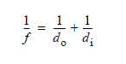

where *f* is focal length, *d*o is the distance between the object and the lens, and *d*i is the distance between the image and the lens. By measuring *d*o and *d*i the focal length can be determined. Magnification, *M*, is the ratio of image size to object size. If the image is inverted, *M* is negative.

**Part I: Object at Infinity**

In this part, you will determine the focal length of the lens by making a single measurement of *d*i with *do≈ ∞*

2. Use the Thin Lens Formula to calculate the focal length.

f = _______________

**Part II: Object Closer Than Infinity**

In this part, you will determine the focal length by measuring several pairs of object and image distances and plotting 1/do versus 1/di.

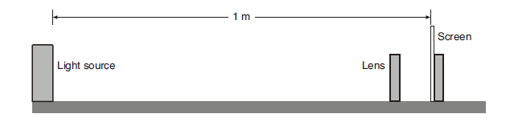 Fig 1

**Procedure**

1. Place the light source and the screen on the optics bench 1 m apart with the light source’s crossed-arrow object toward the screen. Place the lens between them.

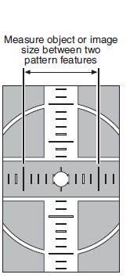2. Starting with the lens close to the screen, slide the lens away from the screen to a position where a clear image of the crossed-arrow object is formed on the screen. Measure the image distance and the object distance. Record these measurements (and all measurements from the following steps) in Table 1.

3. Measure the object size and the image size for this position of the lens.

4. Without moving the screen or the light source, move the lens to a second position where the image is in focus. Measure the image distance and the object distance.

5. Measure the object size and image size for this position also. Note that you will not see the entire crossed-arrow pattern. Instead, measure the image and object sizes as the distance between two index marks on the pattern (see Figure 2 for example).

6. Repeat steps 2 and 4 with light source-to-screen distances of 90 cm, 80 cm, 70 cm, 60 cm, and 50 cm. For each light source-to-screen distance, find two lens positions where clear images are formed. (You don’t need to measure image and object sizes.).

**Analysis Part A: Focal Length**

1. Calculate 1/do and 1/di for all 12 rows in Table 1.

2. Plot 1/do versus 1/di and find the best-fit line (linear fit). This will give a straight line with the x- and y-intercepts equal to 1/f. Record the intercepts (including units) here:

y-intercept = 1/f = _______________

x-intercept = 1/f = _______________

Note: You can plot the data and find the best-fit line on paper or on a computer.

3. For each intercept, calculate a value of f and record it in Table 2.

4. Find the percent difference between these two values of f and record them in Table 2.

5. Average these two values of f. Find the percent difference between this average and the focal length that you found in Part I. Record these data in Table 2.

**Table 1**

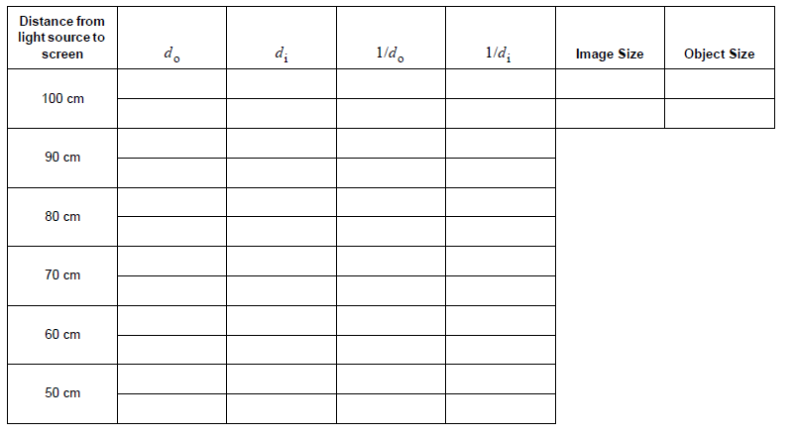

**Table 2**

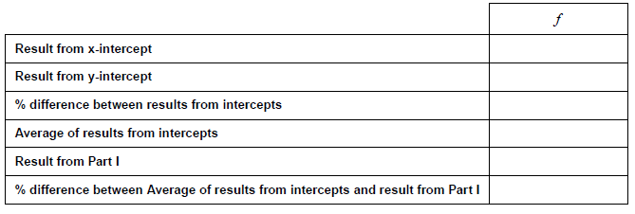

**Analysis Part B: Magnification**

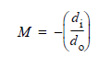1. For the first two data points only (the first two lines of Table 2), use the image and object distances to calculate the magnification, M, at each position of the lens. Record the results in Table 3.

2. Calculate the absolute value of M (for each of the two lens positions) using your measurements of the image size and object size. Record the results in Table 3.

3.PNG

3. Calculate the percent differences between the absolute values of M found using the two methods. Record the results in Table 3.

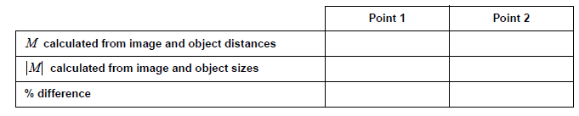**Table 3: Magnification**

**Questions:**

1. Is the image formed by the lens upright or inverted?

2. Is the image real or virtual? How do you know?

3. Explain why, for a given screen-to-object distance, there are two lens positions where a clear image forms.

4. By looking at the image, how can you tell that the magnification is negative?

5. You made three separate determinations of f (by measuring it directly with a distant object, from the x-intercept of your graph, and from the y-intercept). Where these three values equal? If they were not, what might account for the variation?

**Lab #09**

**Object:** ­ To determine the focal length of a concave mirror and to measure the magnification for a certain combination of object and image distances.

**Apparatus:**

* Basic optics system

1. Light Source
2. Bench
3. Concave/convex Mirror
4. Half-screen
5. Metric ruler
6. Optics Caliper (optional, for measuring image sizes)

* PASCO part OS-8468

**Theory:**

For a spherically curved mirror:



Eq 1

where f is focal length, do is the distance between the object and the mirror, and di is the distance between the image and the mirror. By measuring do and di the focal length can be determined. Magnification, M, is the ratio of image size to object size. If the image is inverted, M is negative.

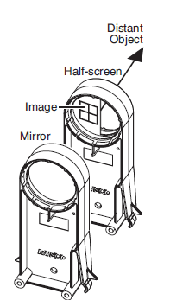

**Part I: Object at Infinity**

In this part, you will determine the focal length of the mirror by making a single measurement of *d*i with *do≈ ∞.*

**Procedure**

1. Hold the mirror in one hand and the half-screen in the other hand. Use the concave side of the mirror to focus the image of a distant bright object (such as a window or lamp across the room) on the half-screen. (See Figure)

2. Have your partner measure the distance from the mirror to the screen. This is the image distance, di.

di = _______________

**Analysis**

Fig 1

1. As *d*o approaches infinity, what does 1/*d*o approach?
2. Use the Equation 13.1 to calculate the focal length.

*f* = _______________

**Part II: Object Closer Than Infinity**

In this part, you will determine the focal length of the mirror by measuring several pairs of object and image distances and plotting 1/do versus 1/di.

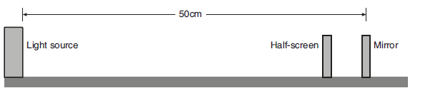

Fig 2

**Procedure**

1. Place the light source and the mirror on the optics bench 50 cm apart with the 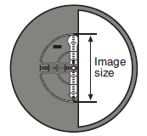light source’s crossed-arrow object toward the mirror and the concave side of the mirror toward the light source. Place the half-screen between them (see Figure 2).

2. Slide the half-screen to a position where a clear image of the crossed-arrow object is formed. Measure the image distance and the object distance. Record these measurements (and all measurements from the following steps) in Table 1.

3. Repeat step 2 with object distances of 45 cm, 40 cm, 35 cm, 30 cm, 25 cm.

Fig 3

4. With the mirror at 25 cm from the light source and a clear image formed on the half-screen, measure the object size and image size. To measure the image size, hold a small scrap of paper against the half-screen and mark two opposite points on the crossed-arrow pattern (see Figure 3). If at least half of the pattern is not visible on the screen, have your partner slightly twist the mirror to bring more of the image into view. Remove the paper and measure between the points. Measure the object size between the corresponding points directly on the light source.

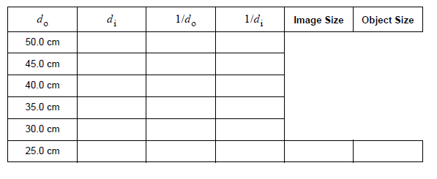**Table 1: Image and Object Distances**

**Analysis Part A: Focal Length**

1. Calculate 1/do and 1/di for all six rows in Table 1.

2. Plot 1/do versus 1/di and find the best-fit line (linear fit). This will give a straight line with the x- and y-intercepts equal to 1/f. Record the intercepts (including units) here:

y-intercept = 1/f = _______________

x-intercept = 1/f = _______________

Note: You can plot the data and find the best-fit line on paper or on a computer.

3. For each intercept, calculate a value of f and record it in Table 2.

4. Find the percent difference between these two values of f and record them in Table 2.

5. Average these two values of f. Find the percent difference between this average and the focal length that you found in Part I. Record these data in Table 13.2.

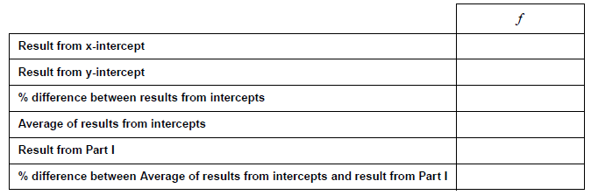**Table 2: Focal Length**

**Analysis Part B: Magnification**

1. For the last data point only (do = 25 cm), use the image and object distances to calculate the magnification, M. Record the results in Table 3.

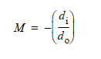

(eq. 2)

2. Calculate the absolute value of M using your measurements of the image size and object size. Record the results in Table 3.

14.PNG

(eq. 13.3)

**Table 3: Magnification**

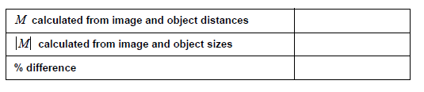

**Questions:**

1. Is the image formed by the mirror upright or inverted?

2. Is the image real or virtual? How do you know?

3. By looking at the image, how can you tell that the magnification is negative?

4. You made three separate determinations of f (by measuring it directly with a distant object, from the x-intercept of your graph, and from the y-intercept). Where these three values equal? If they were not, what might account for the variation?

**Lab #10**

**Object:** To practice determining the critical angle at which total internal reflection occurs in the acrylic trapezoid and confirm your result using Snell’s Law.

**Apparatus:**

* Light Source
* Trapezoid from Ray Optics Kit
* Protractor
* 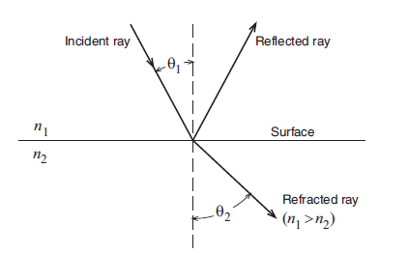White paper

**Theory:**

For light crossing the boundary between two transparent materials, Snell’s Law states

n1sin θ1 = n2sin θ2

where θ1 is the angle of incidence, θ2 is the angle of refraction, and n1 and n2 are the respective indices of refraction of the materials (see Figure 1).

Fig 1

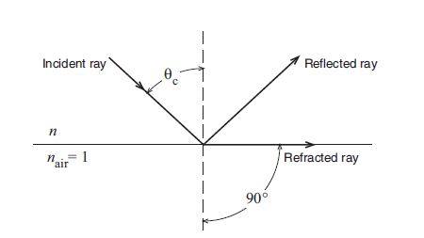In this experiment, you will study a ray as it passes out of the trapezoid, from acrylic (n = 1.5) to air (nair = 1). If the incident angle (θ1) is greater than the critical angle (θc), there is no refracted ray and total internal reflection occurs. If θ1 = θc, the angle of the refracted ray (θ2) is 90°, as in Figure 2.

In this case, Snell’s Law states:

n sin θc = 1 sin 90°

Solving for the sine of critical angle gives:

**1.PNG**

Fig 2

**Procedure**

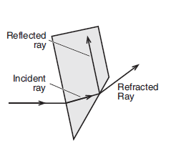**1.** Place the light source in ray-box mode on a sheet of white paper. Turn the wheel to select a single ray.

**2.** Position the trapezoid as shown in Figure 3, with the ray entering the trapezoid at least 2 cm from the tip.

**3.** Rotate the trapezoid until the emerging ray just barely disappears. Just as it disappears, the ray separates into colors. The trapezoid is correctly positioned if the red has just disappeared.

**4.** Mark the surfaces of the trapezoid. Mark exactly the point on the surface where the ray is internally reflected. Also mark the entrance point of the incident ray and the exit point of the reflected ray.

Fig 3

**5.** Remove the trapezoid and draw the rays that are incident upon and reflected from the inside surface of the trapezoid. See Figure 4. Measure the angle between these rays using a protractor. (Extend these rays to

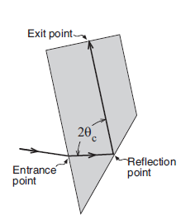make the protractor easier to use.) Note that this angle is twice the critical angle because the angle of incidence equals the angle of reflection.

Fig 4

Record the critical angle here:

θc = _______ (experimental)

**6.** Calculate the critical angle using Snell’s Law and the given index of refraction for Acrylic (*n* = 1.5). Record the theoretical value here:

θc = _______ (theoretical)

**7.** Calculate the percent difference between the measured and theoretical values:

% difference = _______

**Questions:**

1. How does the brightness of the internally reflected ray change when the incident angle changes from less than θc to greater than θc?

2. Is the critical angle greater for red light or violet light? What does this tell you about the index of refraction?

**Lab #11**

**Object:**

To determine the unknown resistance by using a neon flash lamp and a capacitor

**Apparatus:**

* Power Supply (220 VAC)
* Neon flash lamp
* Capacitor (2.2 µF)
* Unknown resistance of the order of Mega Ohm (1,2,3,4,5,6 MΩ) unknown high resistance and stop watch

**Diagram:**



**Procedure:**

1. Sketch the scheme of connection.
2. Connect the neon flash lamp to the AC supply through the unknown resistance R and a capacitor of known capacitance. Put a multimeter with appropriate adjustment across the neon lamp to measure the striking voltage for it.
3. Measure the AC voltage Vo with a multimeter so that the AC voltage greater than the striking value of the lamp may be applied.
4. Now switch on the AC supply and simultaneously start the stop watch. Stop the watch and read off the multimeter when the lamp glows. Any time lag between stopping of the watch and noting the reading of the multimeter may introduce an appreciable error, because the voltage across the capacitor at the time of glow may fall abruptly due to the capacitor discharge which is short circuited by the lamp glow. This gives you the striking voltage V.
5. Take a number of readings for V. Work out the unknown resistance R by the expression

R = t/2.303 C log (1 + V/Vo)

Determine the mean value for Rand record your observations.

**Observation:**

A.C Voltage = Vo = _______ Volts

|  |  |  |  |  |  |  |  |  |
| --- | --- | --- | --- | --- | --- | --- | --- | --- |
| **S.No.** | **Capacitance**  **(µF)** | **Striking Voltage**  **Volts (V)** | | | **Time (t)**  **Sec** | | | **R=t/2.303 C log(1+V/Vo)** |
|  |  |  |  |  |  |  |  |  |
|  |  |  |  |
|  |  |  |  |
|  |  |  |  |  |  |  |  |  |
|  |  |  |  |
|  |  |  |  |
|  |  |  |  |  |  |  |  |  |
|  |  |  |  |
|  |  |  |  |

**Sources of error & precautions:**

1. The AC supply voltage should be greater than the striking voltage for the lamp.
2. Reading for time and striking voltage should be noted at the instance when the lamp just glows.
3. The stop watch should be started at the same time when AC supply is switched on.

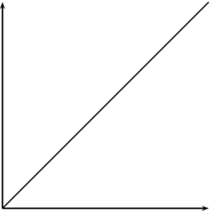

**Lab #12**

**Object:**

To study an ACCEPTOR CIRCUIT and find the value of INDUCTANCE

**Apparatus:**

* Frequency generator,
* Capacitor,
* Resistor,
* Inductor.

**Working formula:**

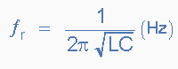

* fr = Resonant Frequency
* L = Inductance
* C = Capacitance

(When R is negligible)

**Theory:**

* At one particular frequency depending on the exact values of C and L, the capacitive and inductive reactance will be equal and opposite.
* Under this condition, called resonance, the impedance of the circuit will be minimum, equal to R and the current will be maximum.
* Resonance is a very important phenomenon as it is used to select a desired frequency from other unwanted frequencies.
* The current and impedance will vary with the frequency.
* The e.m.f applied across such a circuit has to overcome opposition offered by all the above three circuit elements.
* Amplitude of current can assume a maximum value if the impedance becomes minimum and this become feasible.
* The current is zero both for very low and very high frequencies.
* For any other values of frequency, the value of the current depends on the reactance.
* If the frequency is increased, the inductive reactance increases till the frequency has such a value that the inductive reactance is equal to the capacitive reactance.
* Condition for maximum current to flow, this frequency is called the resonant frequency.
* We see that at resonate frequency inductive reactance cancels the capacitive reactance and the current are then entirely determined by the resistive element R of the circuit.
* At this frequency the impedance is minimum and it is equal to R and the current is in phase with the applied voltage.
* If the frequency of the applied voltage is further increased beyond the resonant frequency then the inductive reactance will increase and so the current will go in decreasing.
* Such a circuit is called a series resonant or most commonly an acceptor circuit because at the resonance frequency the impedance is minimum and they therefore accept maximum current at this frequency.
* The frequency at which a certain coil and capacitor resonate when connected together can be found by equating the inductive and capacitive reactance.
* Thus solving for f:



* The response I vary with frequency f.
* The frequency fo at which the response is maximum is known as resonance frequency.
* The frequencies f1 and f2 on which the response falls down to its maximum value are known as lower and upper half power points respectively.
* The bandwidth ∆f is defined as f1 – f2.

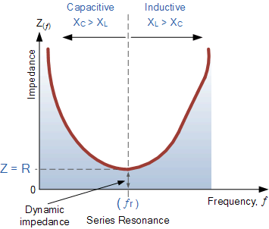

**Diagram:**

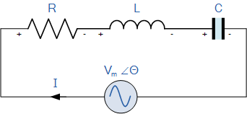

**Procedure:**

1. Check the connections of circuit then turn on the main power of function generator.
2. By setting 100Hz frequency on function generator note down the value of current on ammeter.
3. Repeat the above step for given frequencies.
4. Plot a graph between log F and output of ammeter.
5. Form graph find out the resonant frequency then by taking antilog of that value find the value of inductance.

**Observation:**

|  |  |  |  |
| --- | --- | --- | --- |
| **No. of Observation** | **Frequency F (Hz)** | **I (µA)** | **Log F** |
| **1** |  |  |  |
| **2** |  |  |  |
| **3** |  |  |  |
| **4** |  |  |  |
| **5** |  |  |  |
| **6** |  |  |  |
| **7** |  |  |  |
| **8** |  |  |  |
| **9** |  |  |  |
| **10** |  |  |  |
| **11** |  |  |  |
| **12** |  |  |  |
| **13** |  |  |  |
| **14** |  |  |  |
| **15** |  |  |  |
| **16** |  |  |  |
| **17** |  |  |  |
| **18** |  |  |  |
| **19** |  |  |  |
| **20** |  |  |  |

**Calculation:**

**Result:**

Value of resonant frequency from graph = _______________ Hz.

Value of inductance form formula = ______________ Henry.

**Lab #13**

**Object:**

To study a REJECTOR CIRCUIT and find the value of INDUCTANCE

**Apparatus:**

* Frequency generator,
* Capacitor,
* Resistor,
* Inductor.

**Working formula:**



* fr = Resonant Frequency
* L = Inductance
* C = Capacitance

(When R is negligible)

**Theory:**

* If a coil and capacitor are connected in parallel resonance effects appear when the current of such frequency that the reactance of the coil and the capacitor are equal in mangnitude and opposite in sign.
* At resonance the impedance of a parallel tuned circuit is resistive and is maximum.
* If the coil and the capacitor were perfect reactive components, the impedance at resonance would be infinite.
* In practice the capacitor can be looked upon as a nearly perfect reactance, but there is always appreciable resistance associated with the coil which limits the resonant impedance of the circuit.
* The value of the impedance of a parallel tuned circuit at resonance is called the dynamic resistance of the circuit.
* This is a fictitious resistance and appears to exist only for alternating currents of the resonant frequency.
* The D.C resistance of the circuit is very low.
* Parallel tuned circuits are sometimes called rejecter circuits because at resonance they have they have high impedance and therefore reject current at their resonant frequency.
* The response I very with the frequency f.
* The frequency fo at which the response is minimum is known as resonance frequency.
* The frequency f1 and f2 on which the current rises to under-root 2 times of the minimum current are known as lower and upper half power points respectively.
* The band width ∆f is defined as f2 – f1
* If a resistor, an inductor and a capacitor are connected in parallel and an A.C voltage is applied across them, then in this case it is the voltage rather than current, which is the same on each element of the circuit.
* The current in this case at resonance is minimum.
* This is so because the current in the capacitive branch is in opposite phase to the current in the inductive branch.
* Since the current is rejected by the parallel combination of LC at resonance hence it is termed as the rejecter circuit.
* In this case the impedance is maximum at resonance.
* If there is no resistance in the circuit then the resonant frequency is given by:



**Diagram:**

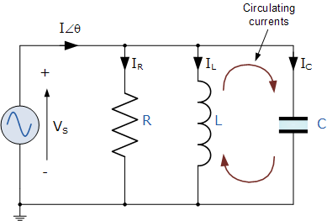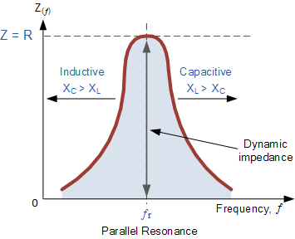

**Procedure:**

1. Check the connections of circuit then turn on the main power of function generator.
2. By setting different frequencies on function generator note down the value of current on ammeter.
3. Repeat the above step for given frequencies.
4. Plot a graph between log F and output of ammeter.
5. Form graph find out the resonant frequency then by taking antilog of that value find the value of inductance.

**Observation:**

|  |  |  |  |
| --- | --- | --- | --- |
| **No. of Observation** | **Frequency F (Hz)** | **I (µA)** | **Log F** |
| **1** |  |  |  |
| **2** |  |  |  |
| **3** |  |  |  |
| **4** |  |  |  |
| **5** |  |  |  |
| **6** |  |  |  |
| **7** |  |  |  |
| **8** |  |  |  |
| **9** |  |  |  |
| **10** |  |  |  |
| **11** |  |  |  |
| **12** |  |  |  |
| **13** |  |  |  |
| **14** |  |  |  |
| **15** |  |  |  |
| **16** |  |  |  |
| **17** |  |  |  |
| **18** |  |  |  |
| **19** |  |  |  |
| **20** |  |  |  |

**Calculations:**

**Result:**

**Lab #14**

**Object:**

To study the variation of electric current with intensity of light using Photocell (The Inverse Square Law of Light)

**Apparatus:**

* Light source fixed,
* Photo cell,
* Ammeter,
* Meter stick,
* Black paper,
* Tape,
* Calculator, and
* Graph paper

**Theory:**

From everyday experience, it is obvious that light sources appear to become brighter as you move closer to them. The apparent brightness of the source is related to its distance. However, moving a light source twice as close to you does not make it twice as bright. In this lab, we will examine this relationship in some detail. For this experiment, we use a light detector (photocell) which enables us to make light intensity measurements that are more precise than those made with the human eye. The photocell converts light intensity to an electrical current, which can be measured with a current meter (ammeter). The current produced by the photocell is directly proportional to the amount of light falling on it. If the light intensity doubles, the meter reading will also double.

Let’s say we have a light source which is on full power and our subject is 1 meter away it. If we move our subject double the distance away from the light (2 meters), how much of the light’s power will reach it? The natural reaction is to think “half power” – but unfortunately that’s now how light works, it follows an inverse-square law.

**According to the law, the power of the light will be inversely proportional to the square of the distance. So if we take a distance of 2 and square it, we get 4, the inverse of which would be 1/4 or rather, a quarter of the original power – not half.**

Moving our subject 3 meters from the light (3 * 3 = 9, so 1/9) the power of our light source now becomes 1/9th of what it originally was.

Here’s how the drops in light power work from 1 to 10 meters, remember that each one is simply the distance squared, over 1.

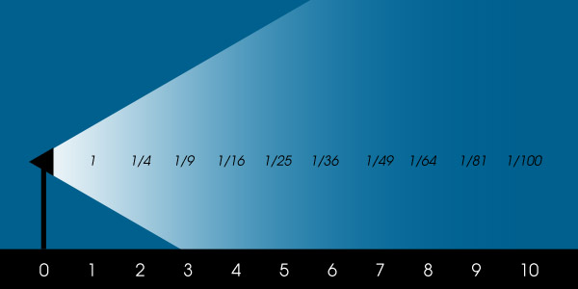

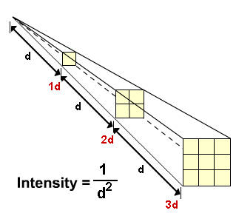

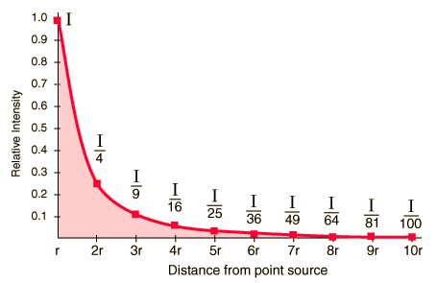

**Procedure:**

It is extremely important to keep stray light out of the detector during this exercise. Moving shadows and reflected light seen by the detector can spoil your results. Avoid unnecessary motion during measurements. In particular, try to keep behind your detector while taking data. Stay close to your experiment while other groups are recording data.

1. Place the light source at a distance, “d," from the detector equal to the 20 cm. “d” is measured from the center of the light bulb to the surface of the detector. Place a sheet of black paper directly in front of the light source, blocking the light going to the detector from the source. Read the current meter and record your reading in Table 1 in the column marked “background.” This reading gives the background intensity resulting from stray light in the room. Remove the black paper and record the meter reading in the column marked “source & background.” Subtract “background” from “source & background” and enter this value in the column marked “source.”
2. Repeat the above procedure for the other distances indicated in Table 1.
3. Next replace the light bulb with one of a lower wattage (intensity). Follow the sameprocedure as above for the new intensity and record your data in Table 2. On a sheet of graph paper, plot your data with distance along the horizontal axis and current (light intensity) along the vertical axis. Draw two smooth curves that best fit your data points, one for each intensity of the light bulb. Label these curves “high intensity” and “low intensity.”

**Observation:**

*Table 1.High Intensity Source 100 WATT Bulb*

|  |  |  |  |  |  |
| --- | --- | --- | --- | --- | --- |
| **S. No.** | **Distance** | **Background** | **Source & Background** | **Source** | **Relative Intensity** |
| **1** | **20 cm** |  |  |  |  |
| **2** | **30 cm** |  |  |  |  |
| **3** | **40 cm** |  |  |  |  |
| **4** | **50 cm** |  |  |  |  |
| **5** | **60 cm** |  |  |  |  |
| **6** | **70 cm** |  |  |  |  |

*Table 2.Low Intensity Source 60 WATT Bulb*

|  |  |  |  |  |  |
| --- | --- | --- | --- | --- | --- |
| **S. No.** | **Distance** | **Background** | **Source & Background** | **Source** | **Relative Intensity** |
| **1** | **20 cm** |  |  |  |  |
| **2** | **30 cm** |  |  |  |  |
| **3** | **40 cm** |  |  |  |  |
| **4** | **50 cm** |  |  |  |  |
| **5** | **60 cm** |  |  |  |  |
| **6** | **70 cm** |  |  |  |  |

**Working formula:**

* Intensity (I) = 1/d2

**Calculations:**

**Result:**

**Lab #15(a)**

**Object:**

To determine the capacity (inner volume) of a given test tube using vernier calipers.

**Apparatus:**

1. Vernier calipers
2. Test tube

**Theory:**

***Least Count***

Least count is the smallest reading that can be taken by an instrument.

*Least Count = Value of smallest division on main scale/ Total number of divisions on vernier scale*

***Zero Error***

Zero error (Z) is the non-coincidence of the zero of the main scale (M.S) and zero of the vernier scale (V.S), when the two jaws of the vernier calipers touch each other:

1. If zero of the vernier scale lies on the right of the main scale then the zero error is positive. Its value is always subtracted from the Total Reading.
2. If zero of the vernier scale lies on the left of the main scale, then the zero error is negative. Its value is always added to the total reading.

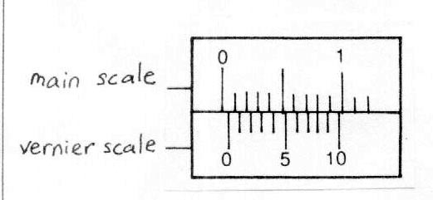

**Working formula:**

1. Volume of the cylinder V = \pi r^2 lcm^3,

V= volume of cylinder, r = radius of cylinder *l* = length of cylinder.

1. Least count of vernier calipers L.C = \frac{S}{N}cm,

S = value of smallest division on the main scale, N = Number of vernier divisions.

**Procedure:**

* First we have to determine the least count of the given vernier calipers.
* Close the two jaws of calipers to find out zero error. If the vernier scale zero exactly coincides with the main scale zero, there is no zero error. But, if it is otherwise, there is some instrumental error, calculate this accordingly. Take three reading for the zero error, if any, and find the mean value.
* To measure capacity (inner volume) of a given test tube use depth gauge of the verniercalipers to measure the internal depth (L). Now by using upper jaws of the vernier calipers measure the internal diameter of test tube and calculate its radius in the same manner.
* Calculate the capacity of the test tube by using formula V = π r2L

**Observation:**

1. The smallest division on main scale S = 0.1 cm
2. Total number of divisions on vernier scale N = 10 div
3. L.C = S/N = ________ cm

* Least Count (LC) = value of smallest division on the main scale/no. of division on cornier scale.

**Table for Length and Diameter:**

|  |  |  |  |  |  |  |  |
| --- | --- | --- | --- | --- | --- | --- | --- |
| **Quantities to be Measured** | **S.No** | **Main Scale Reading**  **(MR cm)** | **Coincident Vernier Div.**  **(VR Div)** | **Fractional Part**  **FP=VR*LC (cm)** | **Total Reading**  **T=MR+FP (cm)** | **Corrected Reading**  **CR=T-Z (cm)** | **Mean Reading (cm)** |
| **Internal Depth of Test Tube (L)** | **1**  **2**  **3** |  |  |  |  |  |  |
| **Internal Diameter of Test Tube (D)** | **1**  **2**  **3** |  |  |  |  |  |  |

Internal radius of test tube r = D/2 = _________________ cm

**Calculations:**

For Capacity of Test Tube:

V = π r2L

V = ________ cm3

**Result:**

Capacity of the given test tube = _____________ cm3

**Sources of Error:**

1. The vernier calipers may have zero error which might have been disregarded.
2. The surface of object under observation may not be smooth.
3. The object between the jaws might be very tightly pressed or it might be too loose.
4. The bottom of test tube is hemispherical.

**Precaution:**

1. To avoid the error due to the uneven surface, the observations should be taken at different points of an object and their mean value should be calculated.
2. Do not apply much force on test tube otherwise it will be broken by the vernier jaws.
3. Vernier reading should be observed normally.
4. Zero error should be observed carefully.

**Lab #15(b)**

**Object:**

To determine the Volume (V) of the given metallic sphere using micrometer screw gauge.

**Apparatus:**

* A micrometer screw gauge
* A small solid sphere

**Theory:**

A screw pitch gauge also known as a micrometer is a precision instrument. It is used for measuring diameter of circular objects mostly wires, with an accuracy of 0.001cm. It consists of a hollow cylinder mounted on a U frame. The hollow cylinder leads to a ratchet which is meant for fine adjustment. The U frame consists of a flat end known as stud and a screw on the other side. This screw can be moved inside the nut by fitted in the U frame by rotating the hollow cylinder called the thimble. This is called the main scale. The hollow cylinder or the thimble is graduated into 50 or 100 equal parts. This is called the circular scale.

Micrometer screw-gauge is another instrument used for measuring accurately the diameter of a thin wire or the thickness of a sheet of metal.It consists of a U-shaped frame fitted with a screwed spindle which is attached to a thimble.

##### F:\Engr; Mirza A.A. Baig\Applied Physics\micrometer-screw-gauge.jpeg

**Fig: Screwgauge**

The screw has a known pitch such as 0.5 mm. Pitch of the screw is the distance moved by the spindle per revolution. Hence in this case, for one revolution of the screw the spindle moves forward or backward 0.5 mm. This movement of the spindle is shown on an engraved linear millimeter scale on the sleeve. On the thimble there is a circular scale which is divided into 50 or 100 equal parts.

**Pitch = distance covered on main scale/number of rotations**

**P = d/N**

When the anvil and spindle end are brought in contact, the edge of the circular scale should be at the zero of the sleeve (linear scale) and the zero of the circular scale should be opposite to the datum line of the sleeve. If the zero is not coinciding with the datum line, there will be a positive or negative zero error as shown in figure below.

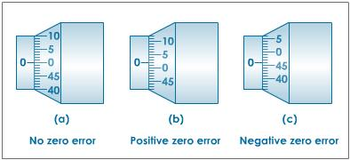

**Fig: Zero error in case of screw gauge**

* If the zero of the circular scale lies below the reference line, the zero error is positive.
* If the zero of the circular scale lies above the reference line, the zero error is negative.

**To take a reading:**

* First look at the main scale. This has a linear scale reading on it. The long lines are every millimeter the shorter ones denote half a millimeter in between.
* On the diagram this reading is 2.5 mm
* Now look at the rotating scale. That denotes 46 divisions - each division is 0.01mm so we have 0.46mm from this scale.

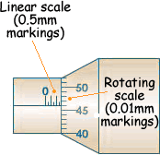

**Working formula:**

* Volume of a Sphere V = 4/3 π r3

**Procedure:**

1. Determine pitch of the given screw gauge.
2. Calculate least count of the screw gauge.
3. Using the ratchet head, close the studs gently. Take three readings for the zero error. Find the mean value (Z).
4. Unscrew the instrument and place the given sphere between the studs. Screw up gently using ratchet until screw is gripped. Note the last visible division of the main scale and convert this main scale reading into centimeters. This is MS! Take the circular scale reading (CS) against the reference line (or index line). Record it in divisions. Multiply CS with the least count (LS) to get the fractional part (FP).
5. Calculate total reading (T) by adding MS and FP (T=MS+FP)
6. Subtract zero error (Z) from the total reading (T) to correct the reading (R=T-Z).
7. Repeat the observation three times at different places and calculate the mean.
8. Calculate the radius of the sphere (R= D/2)
9. Calculate volume of the sphere by the formula V= 4/3πr3

**Observation:**

1. **Pitch:**
2. The smallest division on main scale = ____ mm = ____ cm
3. Total number of divisions or circular scale = ____ div

|  |  |  |  |  |
| --- | --- | --- | --- | --- |
| **S.No.** | **Number of Rotations (N)** | **Distance on M.S (d) mm** | **Pitch P = d/N** | **Mean Pitch** |
| **1** |  |  |  |  |
| **2** |  |  |  |  |
| **3** |  |  |  |  |

1. **Least Count:**

Least count = pitch / Total number of circular scale division

L.C = _______

1. **Diameter:**

|  |  |  |  |  |  |  |
| --- | --- | --- | --- | --- | --- | --- |
| **S.No.** | **Main Scale Reading (MSR) cm** | **Circular Scale Reading (CSR) div** | **Fractional Part**  **FP = CS*LC**  **cm** | **Total Reading**  **T = MS+FP**  **cm** | **Corrected Reading**  **R = T-Z**  **cm** | **Mean (cm)** |
| **1** |  |  |  |  |  |  |
| **2** |  |  |  |  |  |  |
| **3** |  |  |  |  |  |  |

**Calculations:**

**Volume of sphere (V)**

* Mean Diameter D = __________ cm
* Radius R = D/2 = ____________ cm
* Volume V = 4/3 π r3 = _________ cm3

**Result:**

Volume of the given sphere = ____________ cm3

**Precaution:**

1. The object should not be pressed very hard between the two studs.
2. The readings should be taken at various position of the object.
3. The ratchet should be used for screwing and not the drum.
4. Zero error should be checked and recorded.
5. The screw should be rotated in one direction to avoid acklash error.

**Sources of Error:**

1. Mechanical imperfections in the sphere.
2. Undue pressure on the thread of the screw and the object.
3. Backlash error due to the loose movement of the screw in the nut.
4. Dust particles on the faces of the anvil and spindle.
5. The looseness of the screw in its nut and it may possess lateral motion.
6. Human error.

**Lab #16**

**Object:**

Determination the moment of inertia of a flywheel.

**Apparatus:**

* Flywheel
* String
* Weight
* Vernier Caliper
* Stop watch

**Working formula:**

Decent of the string before detachment of weight

**h=2πrn1**

Angular speed of fly wheel:

**ω=4πrn2/t**

Moment of inertia of fly wheel

**I= M{[ – r2]/[1+]}**

Where:

I is the moment of inertia of the fly wheel (gm/cm2)

M is the mass attached to the string (gm)

g is the acceleration due to gravity (9.8 m/s2 = 980 cm/s2)

h is the height descended by the mass on just before detachment (cm)

Ш is the average angular speed (rad/sec)

r is the radius of the axle (cm)

n1 is the number of turns of the string on the axle

n2 is the number of rotations of made by the flywheel after the detachment of string and before it comes to rest.

**Procedure:**

1. Note down the least counts of Vernier Caliper and Stop watch
2. Measure the diameter of the axel using Vernier Caliper from three different positions, find out mean diameter, and then the radius of the flywheel
3. Attach a mass with one end of the string. Make a small loop at other end of the string so that the mass can be hanged from the knob on the axle
4. Give five turns (n1) to the wheel so that string winds evenly around the axle
5. Allow the mass to descend to the floor
6. As soon as string detaches note down simultaneously the time taken by the flywheel and number of rotations it makes till it comes to rest. Repeat this step three times
7. Repeat steps (4) to (6) for n1 = 7 and n2 = 9

**Observation:**

|  |  |  |  |  |  |
| --- | --- | --- | --- | --- | --- |
| **S.No.** | **Main Scale Reading MSR (cm)** | **Vernier Scale Reading VSR (Div)** | **Diameter of the axle = MSR+LSR*Least count (cm)** | **Mean diameter (cm)** | **Radius of the axle r = d/2 (cm)** |
| **1** |  |  |  |  |  |
| **2** |  |  |  |  |  |
| **3** |  |  |  |  |  |

Measurement of time and no. of rotations of wheel before it come to rest

|  |  |  |  |  |  |
| --- | --- | --- | --- | --- | --- |
| **S.No.** | **No. of turn of string on axle n1** | **No. of rotations after the detachment of string n2** | **Mean** | **Time taken by the wheel before coming to rest (sec)** | **Mean time (sec)** |
| **1** |  |  |  |  |  |
| **2** |  |  |  |  |  |
| **3** |  |  |  |  |  |

**Calculations:**

|  |  |  |  |  |
| --- | --- | --- | --- | --- |
| **S.No.** | **h1** | **h2** | **h3** | **“Mean h”** |
|  |  |  |  |  |

|  |  |  |  |  |
| --- | --- | --- | --- | --- |
| **S.No.** | **Ш1** | **Ш2** | **Ш3** | **“Mean Ш”** |
|  |  |  |  |  |

|  |  |  |  |  |
| --- | --- | --- | --- | --- |
| **S.No.** | **I1** | **I2** | **I3** | **“Mean I”** |
|  |  |  |  |  |

Height descended by the string before detachment of string = h = 2πrn1 = _________ cm

Average angular speed of the flywheel = Ш = 4 πrn2 /t = _________ rad/sec

Calculate moment of inertia for n1 = 5, 7, 9. Find mean moment of inertia.

**Result:**

The moment of inertia of the flywheel is found to be = ______________ gm/cm2

**Precaution and Sources of Error:**

1. Axel ball bearing must be properly lubricated.
2. The diameter of the axle must be measured carefully.
3. String must be wound evenly on the axle.
4. Time and number of rotations n2 must be measured simultaneously.
5. The length of string must be such that it slops off the knob easily before the mass is about to touch the ground.
6. Number of rotations n2 must be counted carefully.